Performance Optimization of Pin Fin Heat Sink using Multi-Objective Evolutionary Algorithm and Pareto Analysis.
Sharvin Tagunde
University of Texas at Dallas, Eric Johnson School of Engineering, Department of Mechanical Engineering

A B S T R A C T
This study presents a systematic multi-objective optimization framework for the geometric design of a pin–fin heat sink intended for forced convection air cooling under moderate heat loads. The objectives of interest include minimizing thermal resistance, minimizing pressure drop, and reducing heat sink mass, while simultaneously exploring discrete material selection between aluminum and silicon. A Latin Hypercube Sampling (LHS) based Design of Experiments (DOE) is first performed to evaluate hydrothermal behavior for a wide range of pin–fin diameters, heights, spacings, and base thicknesses. The resulting dataset is used to construct high-fidelity surrogate models using Gaussian Process Regression (GPR), Artificial Neural Networks (ANN), Radial Basis Functions (RBF), and polynomial regression. The most accurate surrogate for each objective is selected using MAE, RMSE, and R² metrics, enabling efficient prediction across the design space without repeated CFD or numerical evaluations.
A customized mixed-variable NSGA-II algorithm is then implemented to simultaneously optimize the continuous geometric variables and the discrete material choice. The algorithm produces a well-distributed Pareto front capturing the competing trade-offs among thermal resistance, pressure drop, and mass for both materials. Multi-criteria decision-making (MCDM) methods, TOPSIS, LINMAP, and VIKOR are subsequently applied to extract representative optimal solutions that balance thermal performance and hydraulic losses. Finally, the selected designs are validated through detailed CFD simulations in ANSYS Fluent, confirming that all optimized configurations maintain safe chip temperatures and acceptable pressure drops under a 10 W heat load.
The results demonstrate that the surrogate-assisted NSGA-II framework reliably identifies high-performance heat sink geometries with significantly reduced computational cost. The methodology provides a generalized and efficient pathway for multi-objective thermal–fluid optimization of pin–fin heat sinks and similar electronic cooling components.

A R T I C L E I N F O
Keywords:
Multi-objective optimization
Heat sink design
Surrogate modeling
Gaussian Process Regression (GPR)
Artificial Neural Network (ANN)
Latin Hypercube Sampling (LHS)
NSGA-II algorithm
Mixed-variable optimization
Computational Fluid Dynamics (CFD)
Thermal resistance minimization
Pressure drop analysis
Pareto front
Multi-criteria decision-making (MCDM)
TOPSIS / LINMAP / VIKOR
Parametric design exploration

1. Introduction
The continuous increase in power density in compact electronic devices has intensified the demand for reliable and efficient thermal management solutions. Among passive cooling strategies, pin–fin heat sinks remain widely deployed due to their manufacturability, large surface-area-to-volume ratio, and strong thermal performance under forced convection. The hydrothermal behavior of pin–fin arrays is highly sensitive to geometric parameters such as pin diameter, height, spacing, and base thickness, as well as material properties, motivating systematic design exploration and optimization to balance thermal resistance, pressure drop, and material usage. Prior studies have demonstrated that modifying fin geometry, arrangement, and structural features can significantly influence heat transfer coefficients, flow development, and overall thermal resistance. However, direct CFD-based optimization of heat-sink geometries remains computationally prohibitive due to the large design space and the need for repeated evaluations across varied operating and geometric conditions.
To address these limitations, recent thermal-design literature has increasingly adopted surrogate-assisted, multi-objective optimization frameworks, where high-fidelity data is used to train predictive models that replace expensive simulations during exploration. Such approaches enable the use of evolutionary algorithms, including NSGA-II, to identify Pareto-optimal designs representing the trade-offs between thermal and hydraulic performance metrics. Nevertheless, the combined treatment of mixed continuous–discrete variables, specifically material selection alongside geometric design variables, remains less explored in pin–fin heat-sink optimization.
The proposed framework provides an efficient and generalizable methodology for thermal–hydraulic optimization of pin–fin heat sinks, enabling accurate performance prediction at significantly reduced computational cost while preserving physical fidelity through final CFD verification.

2. Numerical Simulation

2.1 Geometry Description

The computational domain consists of a 15 mm × 15 mm × 2 mm silicon chip mounted beneath a 60 mm × 60 mm heat-sink base, onto which cylindrical pin–fins are extruded according to the optimized geometric parameters. For each selected design, the fin diameter D, height of fin H, spacing S, and base thickness t_{b} are implemented directly from the multi-objective optimization results. The heat sink and chip are enclosed within a rectangular air channel sized to ensure fully developed inflow and outflow conditions at the boundaries. A uniform 10 W volumetric heat source is applied to the chip, while the pin–fin array and enclosure walls participate in conjugate conduction and forced convection.
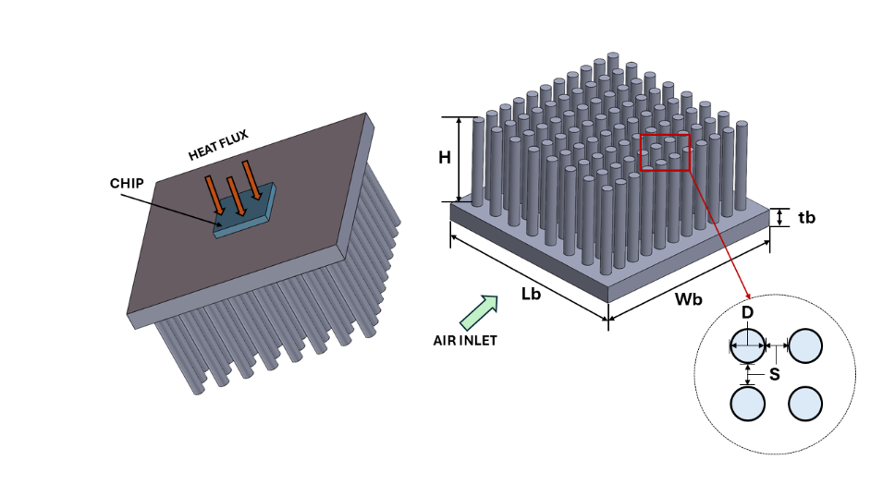
Fig.1. 3D Model Diagram of the Heat Sink Geometry

2.2 Numerical Procedures

A three-dimensional single-phase conjugate heat transfer simulation is computed using the following assumptions:
- The flow is incompressible, Newtonian, and single-phase, the fluid properties are temperature independent.
- Radiation and natural convection effects are negligible relative to forced convection. Gravitational effects are neglected.
- The solid regions of the heat sink and chip are isotropic and homogeneous. Viscous dissipation is ignored,
- The inlet flow is uniform and fully turbulent.

Considering the assumptions above, the fundamental equations governing of flow and heat transfer encompass the following:
- Continuity Equation:
$$∇⋅u=0$$
- Momentum equations (Reynolds-averaged Navier–Stokes):
$$ρ(u⋅∇u)=-∇p+∇⋅[(μ+μ_{t})(∇u+∇u^{T})]$$
$$P_{pump}$$ | Pumping Power, W
$$m_{t}$$ | Discrete Material Variable (Al or Si)
$$ρ_{s}(m_{t})$$ | Density of Material, kg/m³
$$k_{s}(m_{t})$$ | Thermal Conductivity of Material, W/m-K
$$T_{f}$$ | Fluid Temperature, K
$$T_{s}$$ | Solid Temperature, K
u = (u, v, w) | Velocity Vector, m/s
p | Static Pressure, Pa
$$μ_{t}$$ | Turbulent Viscosity, Pa-s
k | Turbulent Kinetic Energy, m²/s²
$${\dot{q}}^{'''}$$ | Volumetric Heat Generation W/m³
ω | Specific Dissipation Rate, s⁻¹
$$k_{t}$$ | Turbulent Thermal Conductivity, W/m-K
$${Pr}_{t}$$ | Turbulent Prandtl Number
$$P_{k}$$ | Production of Turbulent Kinetic Energy, W/kg
F (x,$m_{t}$) | Objective Vector
$$f_{1} \left(x, m_{t}\right)= R_{th}$$ | Thermal Objective, K/W
$$f_{2}\left(x\right)= ΔP$$ | Hydraulic Objective, Pa
$$f_{3}\left(x, m_{t}\right)=M$$ | Mass Objective, kg
x | Continuous Design Vector, mm
$g_{i}$(.) | Constraint Functions

Nomenclature
D | Pin Diameter, mm
H | Pin Height, mm
S | Pin Spacing, mm
$$t_{b}$$ | Heat Sink Base Thickness, mm
$$A_{b}$$ | Exposed Base Area, mm²
$$A_{c}$$ | Minimum Flow cross-section area between pins, mm²
$$P_{c}$$ | Wetted Perimeter of Flow passage, mm
$$D_{h}$$ | Hydraulic Diameter, mm
N | Number of Fins
$$V_{b}$$ | Base Volume, mm³
$$V_{p}$$ | Single Pin Volume, mm³
$$V_{chip}$$ | Chip Volume, mm³
$$V_{total}$$ | Total Heat-Sink Volume, mm³
e | Edge Clearance around Pin array, mm
$$H_{total, max}$$ | Maximum Permissible Heat-Sink Height, mm
$$u_{∞}$$ | Inlet Air Velocity, m/s
$$u_{m}$$ | Mean channel Air Velocity between Pins, m/s
ρ | Air Density, kg/m³
μ | Dynamic Viscosity of Air, Pa-s
$$k_{f}$$ | Air Thermal Conductivity, W/m-K
$$c_{p}$$ | Specific Heat of Air, J/kg-K

$$P_{r}$$ | Air Prandtl Number
$${Re}_{D}$$ | Reynolds Number (Pin Diameter Basis)
$${Re}_{min}, {Re}_{max}$$ | Validity ranges of Correlations
$$\dot{V}$$ | Volumetric Flow Rate, m³/s
$$T_{base}$$ | Heat-Sink Base Temperature, K
$$T_{∞}$$ | Ambient Air Temperature, K
$$T_{max}$$ | Maximum Allowable Base Temperature, K
Q | Applied Heat Load, W
h | Average Convective Heat-Transfer Coefficient, W/m²-K
$$A_{surf}$$ | Total External Surface Area (Fins + Base), m²
$$R_{th}$$ | Thermal Resistance (Base to Ambient), K/W
$$R_{th, max}$$ | Maximum Allowable Thermal Resistance, K/W
$$η_{f}$$ | Fin Efficiency
$$m_{f}$$ | Fin Parameter, m⁻¹
$$A_{f}$$ | Fin Cross-sectional area, m²
$$P_{f}$$ | Fin Perimeter, m
ΔP | Pressure Drop across Pin-fin array, Pa
f | Darcy Friction Factor
$$C_{f}, p_{f}$$ | Empirical, Friction-factor correlation constants

- Energy Equation:
$$ρc_{p}(u⋅∇T_{f})=∇⋅[(k_{f}+k_{t})∇T_{f}]$$
- Conjugate Solid Fluid Coupling:
$$-k_{s} n⋅∇T_{s}=-(k_{f}+k_{t})n⋅∇T_{f}\text{ on }Γ_{sf}$$
In the above equations, the density, velocity, specific heat, dynamic viscosity and thermal conductivity of the fluid are denoted by ρ, u, Cp, μ and k respectively.

2.3 Numerical Model and Evaluation Indices

The numerical model provides the analytical and semi-empirical expressions required to evaluate the thermal–hydraulic performance of each candidate heat-sink design during the DOE, surrogate-modelling, and multi-objective optimization stages.
For a given design, following are variables:
$$Continuous , x=[D, H, S, t_{b}]^{T},{ Discrete , m}_{t}∈\{\text{Al}, \text{Si}\},$$
the following indices are used to evaluate the thermal–hydraulic performance.
(1) Reynolds number
$$Re_{D}=\frac{ρu_{∞}D}{μ},$$
Correlations valid in the corresponding $Re_{D}$ range are adopted for pin-fin arrays.

(2) Hydraulic diameter and flow area
The minimum flow cross-section and wetted perimeter between neighboring pins are
$$A_{c}=S^{2}-\frac{πD^{2}}{4},P_{c}=4S-πD,$$
and the hydraulic diameter is
$$D_{h}=\frac{4A_{c}}{P_{c}}.$$
The mean channel velocity is
$$u_{m}=u_{∞}\frac{S^{2}}{A_{c}}.$$

(3) Heat-transfer coefficient and thermal resistance
The average convective heat-transfer coefficient on the fins and exposed base is estimated from forced-convection correlations for pin-fin arrays:
$$h=C_{h} k_{f}D^{-1}Re_{D}^{ m_{h}}Pr^{ n_{h}},$$
The total external surface area is
$$A_{\text{surf}}=N (πDH+\frac{πD^{2}}{4})+A_{b},$$
where $N$ is the number of pins on the $60×60$mm base and $A_{b}$ is the exposed base area. For an imposed heat load $Q$, the base-to-ambient thermal resistance is
$$R_{\text{th}}(x,m_{t})=\frac{T_{\text{base}}(x,m_{t})-T_{∞}}{Q},$$

with $T_{\text{base}}$ evaluated using standard fin-efficiency-based thermal-resistance networks. Minimizing $R_{\text{th}}$ is equivalent to maximizing heat transfer.

(4) Pressure-drop and pumping power
The pressure drop across the fin array is modeled by
$$ΔP(x)=f(Re_{D}) \frac{H}{D_{h}} \frac{ρu_{m}^{2}}{2},$$
where the Darcy friction factor is expressed as
$$f(Re_{D})=C_{f}Re_{D}^{-p_{f}},$$
with $C_{f},p_{f}$ taken from pin-fin pressure-drop correlations.
The corresponding pumping power is
$$P_{\text{pump}}=ΔP \dot{V},\dot{V}=u_{∞}A_{\text{inlet}}.$$

(5) Mass
The total heat-sink volume is the sum of the base and all pins,
$$V_{\text{tot}}=A_{b}t_{b}+N \frac{πD^{2}}{4}H,$$
and the mass is
$$M(x,m_{t})=ρ_{s}(m_{t}) V_{\text{tot}},$$
where $ρ_{s}(m_{t})$ is the density of the chosen material (Al or Si).
These indices, thermal resistance $R_{\text{th}}$, pressure drop $ΔP$, and mass $M$, constitute the three objective functions in the subsequent multi-objective optimization, while $Re_{D}$, $D_{h}$, and $P_{\text{pump}}$ are used to ensure correlation validity.

Table 1
Thermophysical properties of materials.
Material | Density, ρ [kg/m³] | Specific Heat,  $c_{p}$ [ J/kg-K] | Thermal Conductivity, k [W/m-K] | Dynamic Viscosity, μ [Pa-s]
Air | 1.225 | 1006.4 | 0.0242 | 1.79 × 10⁻⁵
Aluminum | 2700 | 897 | 237 | -
Silicon | 2330 | 703 | 149 | -

3. Methodology
The overall workflow adopted in this study integrates numerical modeling, approximation, and multi-objective optimization. The process begins with defining the operating conditions, design variables, objective functions, and constraints for the heat-sink problem. A numerical model is then formulated to evaluate the objective functions, followed by the development of an optimization formulation. Optimization methods like DOE, Surrogate Models & Evolutionary algorithms are then used to find representative optimal designs. Finally, the chosen configurations are validated using high-fidelity CFD simulations in ANSYS Fluent, to determine the best design trade-off.
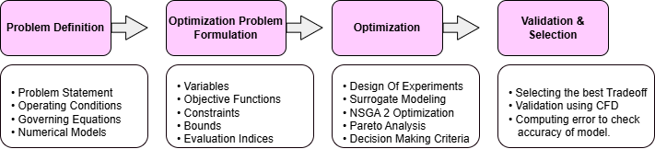
Fig.2. Overall workflow for multi-objective optimization
4. Optimization Problem Formulation
The optimization formulation based on the design variables, objective functions and constraints can be expressed as follows:

$$\underset{x, m_{t}}{min⁡} F(x,m_{t})=[R_{\text{th}}(x,m_{t}), ΔP(x), M(x,m_{t})]^{T}$$
subject to:
$$g_{1}\left(x\right)≥0, g_{2}\left(x\right)≥0, g_{3}\left(x\right)>0, g_{4}\left(x,m_{t}\right)≥0 \\ Re_{min}≤Re_{D}\left(D\right)≤Re_{max} \\ D_{min}≤D≤D_{max}, \\ S_{min}≤S≤S_{max} \\ t_{b,min⁡}≤t_{b}≤t_{b,max⁡} \\ m_{t}∈\{\text{Aluminum}, \text{ Silicon}\}$$

4.1 Design Variables

Considering 4 continuous geometric design variables and 1 discrete material variable:
$$\begin{matrix} & x={\left[D,H,S,t_{b}​\right]}^{T}, m_{t}∈\{Aluminum (Al) ,Silicon (Si)\} & & \end{matrix}$$
- $D$ – pin diameter (m)
- $H$ – pin height (m)
- $S$ – pin spacing in both x and y directions (m)
- $t_{b}$ – base thickness (m)
- $m_{t}$ – heat-sink material: Aluminum (Al) or Silicon (Si)
The base footprint is fixed at $60\text{ mm}×60\text{ mm}$.

4.2 Objective functions

For a given design $(x,m_{t})$, the numerical model provides:
- Overall thermal resistance $R_{\text{th}}(x,m_{t})$
- Pressure-drop $ΔP(x)$ across the fin array
- Mass $M(x,m_{t})$ of the heat sink

The optimization aims to minimize all three of the functions, i.e. “maximizing heat transfer” is expressed as:
$$\underset{x,{ m}_{t}}{minimize⁡} F(x,m_{t})=\left[\begin{aligned}f_{1}(x,m_{t}) \\ f_{2}(x) \\ f_{3}(x,m_{t})\end{aligned}\right]=\left[\begin{aligned}R_{\text{th}}(x,m_{t}) \\ ΔP(x) \\ M(x,m_{t})\end{aligned}\right]$$

4.3 Constraints

The design must satisfy geometric, thermal, and model-validity constraints, together with simple bounds.
- Variable bounds
$$\begin{matrix} & \begin{matrix}D_{min} (2 mm) & ≤ D ≤D_{max}(6 mm) \\ H_{min}(10 mm) & ≤ H ≤H_{\max{,}}(30 mm) \\ S_{min}(5 mm) & ≤ S ≤S_{max}(15 mm) \\ t_{b,\min{,}}(2 mm) & ≤t_{b} ≤t_{b,\max{,}}(6 mm)\end{matrix} & & \end{matrix}$$

- Geometric feasibility

- Pin clearance / non-overlap
$$\begin{matrix} & g_{1}(x)=S-(D+e)≥0 & & \end{matrix}$$
where $e>0$ is a fixed edge/clearance margin.

- Total height (mechanical envelope)
$$\begin{matrix} & g_{2}(x)=H_{\text{tot,max}}-(H+t_{b})≥0 & & \end{matrix}$$
ensuring the heat sink fits inside the available vertical space.

- Positive flow area between pins
$$\begin{matrix} & g_{3}(x)=S^{2}-\frac{πD^{2}}{4}>0 & & \end{matrix}$$
so that the hydraulic channel cross-section is non-zero.
- Thermal constraint
The maximum allowable base temperature $T_{max}$ (60 °C) must not be exceeded:
$$\begin{matrix} & T_{\text{base}}(x,m_{t})≤T_{max} & & \text{(C5)}\end{matrix}$$
Using $T_{\text{base}}=T_{∞}+QR_{\text{th}}$, this can be written directly in terms of thermal resistance:
$$\begin{matrix} & g_{4}(x,m_{t})=R_{\text{th,max}}-R_{\text{th}}(x,m_{t})≥0,R_{\text{th,max}}=\frac{T_{max}-T_{∞}}{Q} & & \end{matrix}$$

- Correlation validity (Reynolds number)
To keep the analytical correlations within their calibrated range:
$$\begin{matrix} & Re_{min}≤Re_{D}(D)≤Re_{max} & & \end{matrix}$$

4.4 Material discreteness
The material choice is restricted to the two candidate materials:
$$\begin{matrix} & m_{t}∈\{\text{Aluminum}, \text{Silicon}\} & & \end{matrix}$$
In practice, this is handled by using mixed integer programming in the evolutionary algorithm stage of the optimization.

5. Optimization
5.1 Optimization Flow Chart
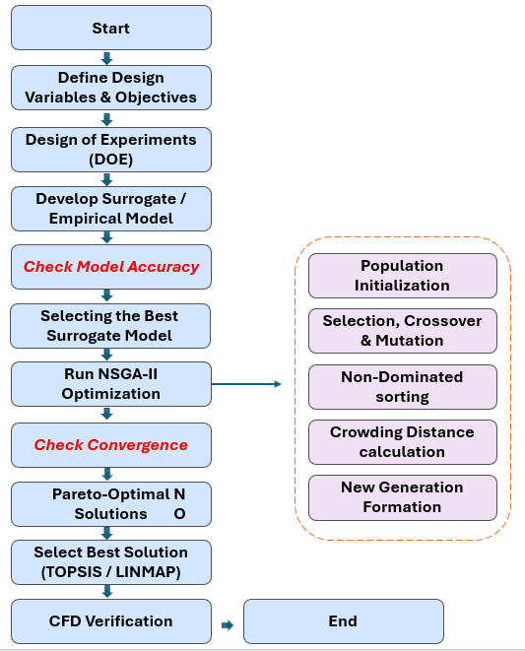
Fig.3. Optimization Flow Chart
5.2 Design of Experiments
To explore the geometric and material design space efficiently, a Latin Hypercube Sampling (LHS) based Design of Experiments was adopted instead of a full factorial grid. The design vector is as follows:
$$x=[D, H, S, t_{b}, m]$$
It includes four continuous variables (pin diameter, height, spacing, and base thickness) and one discrete material index $m∈\{\text{Al},\text{Si}\}$. Each continuous variable was assigned physically realistic bounds based on manufacturability and thermal–hydraulic constraints, and LHS was used to generate 200 space-filling samples that provide good coverage of the multidimensional domain while avoiding clustering.

For each sample, the numerical model was evaluated to compute the corresponding thermal resistance $R_{th}$, pressure drop $ΔP$, and mass $M_{hs}$. Designs violating basic geometric or flow constraints (e.g., minimum spacing, blocked channels) were discarded, resulting in 198 valid designs for aluminum and 195 for silicon. These DOE datasets form the training and validation basis for constructing the surrogate models used in the subsequent optimization stage.

5.3 Surrogate Modeling
The multi-objective optimization problem considered in this study requires repeated evaluation of thermal resistance, pressure drop, and heat-sink mass over a multi-dimensional design space. Direct numerical evaluation for hundreds or thousands of candidate designs is computationally prohibitive. To reduce this cost, surrogate models are constructed as fast analytical approximations of the true numerical responses. These models emulate the behavior of the underlying system within the bounds of the DOE data and allow the NSGA-II algorithm to explore the design space. The expectation is that, for all objectives, the surrogate predictions maintain sufficient accuracy to reliably rank designs and generate valid Pareto front.
5.3.1 Surrogate Model Formulations
For each objective function, four surrogate models are trained and compared. This process is repeated independently for aluminum and silicon to account for their distinct physical properties and response patterns.
1. Polynomial Response Surface
It constructs a low-order polynomial approximation of the form:
$$\hat{y}(x)=β_{0}+\sum_{i}{β_{i}x_{i}}+\sum_{i≤j}{β_{ij}x_{i}x_{j}}+…$$
This model provides a smooth global fit and is effective when the underlying behavior is nearly linear or moderately nonlinear.

2. Radial Basis Function (RBF)
RBF models interpolate the response using a weighted sum of radially symmetric kernel functions:
$$\hat{y}(x)=\sum_{k=1}^{N}{wk​ϕ}\left(\left\|x-x^{(k)}\right\|\right)$$
where $ϕ(⋅)$ maybe Gaussian or multiquadric. RBF models capture nonlinear variations effectively when the response surface is smooth.
3. Gaussian Process Regression (Kriging Method)
GPR treats the response as a realization of a Gaussian random field with covariance kernel:
$$k(x,x')={{σ​}_{f}}^{2}\left(-\sum_{i}{\frac{(x_{i}-{x_{i}}^{'})}{{l_{i}}^{2}}}\right)$$
It provides both a prediction and an uncertainty estimate and performs well when the mapping is smooth and noise-free.
4. Artificial Neural Network (ANN)
A feed-forward ANN with nonlinear activation functions is trained to approximate: $\hat{y}(x)=f_{ANN}(x; θ)$
where $θ$ represents the learned network weights. ANNs can capture highly nonlinear behavior and local fluctuations.
Fig.4. Surrogate model surface plots and true–predicted performance for Aluminum across all three objective functions
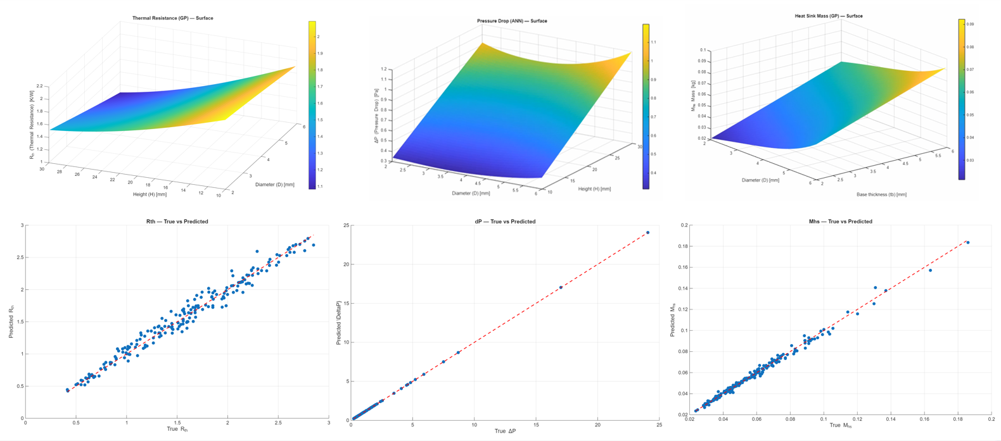
5.3.2 Model Training and Evaluation
All input variables are normalized to the interval $[0,1]$ for numerical stability. The DOE dataset is divided into 80% training and 20% testing, and models are evaluated only on the test data to avoid overfitting. Separate surrogate sets are generated for aluminum and silicon due to their different thermal and physical characteristics. Model accuracy is assessed using standard regression metrics like Mean absolute error (MAE), Root mean square error (RMSE), and coefficient of determination ($R^{2}$) on the test data:
$$MAE=\frac{1}{N}\sum_{i=1}^{N}{\left|y_{i}-{\hat{y}}_{i}\right|}$$
$$RMSE=\sqrt{\frac{1}{N}\sum_{i=1}^{N}{{\left(y_{i}-{\hat{y}}_{i}\right)}^{2}}}$$
$$R^{2}=1-\frac{\sum_{i=1}^{N}{{\left(y_{i}-{\hat{y}}_{i}\right)}^{2}}}{\sum_{i=1}^{N}{{\left(y_{i}-{\overline{y}}_{i}\right)}^{2}}}$$
where $y_{i}$ and ${\hat{y}}_{i}$ are true and predicted values, and $\overset{ˉ}{y}$ is the mean of $y_{i}$.
Low MAE/RMSE and $R^{2}$close to unity indicate a good fit; in our study, all selected models achieved high $R^{2}$ and small errors, confirming adequate predictive capability.
Table 2
Summary of surrogate model performance and selected best models for each objective function.
Objectives | Model | RMSE (Al) | RMSE (Si) | Best Model
Thermal Resistance (Rth) | Polynomial | 0.091959 | 0.092218 | Gaussian Process (GP)
 | GP | 0.078162 | 0.088357
 | RBF | 0.38577 | 0.31189
 | ANN | 0.14402 | 0.11098
Pressure Drop (ΔP) | Polynomial | 1.9717 | 1.4537 | Artificial Neural Network (ANN)
 | GP | 1.2262 | 0.74013
 | RBF | 1.3345 | 1.3584
 | ANN | 0.16061 | 0.53393
Mass of Sink (Mhs) | Polynomial | 0.0058512 | 0.0054143 | Gaussian Process (GP)
 | GP | 0.0027089 | 0.0025483
 | RBF | 0.0091355 | 0.0070478
 | ANN | 0.0030458 | 0.004555
Based on the computed error metrics (Table 2), Gaussian Process Regression (GPR) consistently provides the most accurate approximation for thermal resistance and heat-sink mass, reflecting the smooth, monotonic nature of these responses. In contrast, the pressure drop exhibits sharper nonlinear transitions, particularly with varying spacing and blockage, making the ANN the best-performing surrogate for ΔP.
The same trends are observed for both materials, but each surrogate is trained separately to avoid cross-material interference and to maintain high predictive fidelity. The selected “best” surrogates (GPR for $R_{th}$ and $M_{hs}$; ANN for $ΔP$) are subsequently integrated into the NSGA-II framework for optimization.

5.4 Multi-Objective Optimization using NSGA2 Evolutionary Algorithm
The multi-objective optimization problem which involves minimizing thermal resistance $R_{th}$, pressure drop $ΔP$, and heat-sink mass $M_{hs}$ is solved using the Non-Dominated Sorting Genetic Algorithm II (NSGA-II), a widely adopted evolutionary method for problems involving conflicting objectives and nonlinear constraints. NSGA-II is particularly suitable for this study because the design space is multimodal, includes a discrete material variable, and exhibits strong interactions between geometric parameters, making gradient-based approaches ineffective.

5.4.1 Algorithm Overview

NSGA-II maintains a population of candidate designs and iteratively improves them through genetic operators. Solutions are ranked based on non-dominated sorting, where a design dominates another if it is no worse in all objectives and strictly better in at least one. The algorithm organizes the population into a hierarchy of Pareto fronts, with the first front representing the best trade-off solutions.
To preserve diversity across the Pareto front, NSGA-II employs the crowding distance metric, which quantifies how isolated a solution is with respect to its neighbors in objective space. During selection, solutions with lower rank and larger crowding distance are preferred, ensuring both convergence and spread of solutions.

5.4.2 Integration of Surrogate Models

To enable fast optimization, the surrogate models developed in the surrogate stage are embedded directly into the evaluation step of NSGA-II. For each candidate $x=[D,H,S,t_{b},m]$, the objective values are computed using the corresponding best surrogate model (GPR for $R_{th}$and $M_{hs}$, ANN for $ΔP$). This reduces evaluation time by several orders of magnitude relative to full numerical simulation.
The material variable $m$is treated as a discrete gene, allowing mutation to toggle between aluminum and silicon. The optimizer therefore discovers material-geometry combinations simultaneously, producing a unified multi-material Pareto front.

5.4.3 Genetic Operators and Parameters

The main evolutionary operators are:
- Simulated binary crossover (SBX): Generates offspring by exchanging and recombining parent geometries, controlled by crossover probability $p_{c}$ and distribution index $η_{c}$.
- Polynomial mutation: Perturbs each design variable with probability $p_{m}$, enabling exploration of the local neighborhood.
Fig.5. Convergence plots for NSGA 2 solution for all three objective functions across the generations.
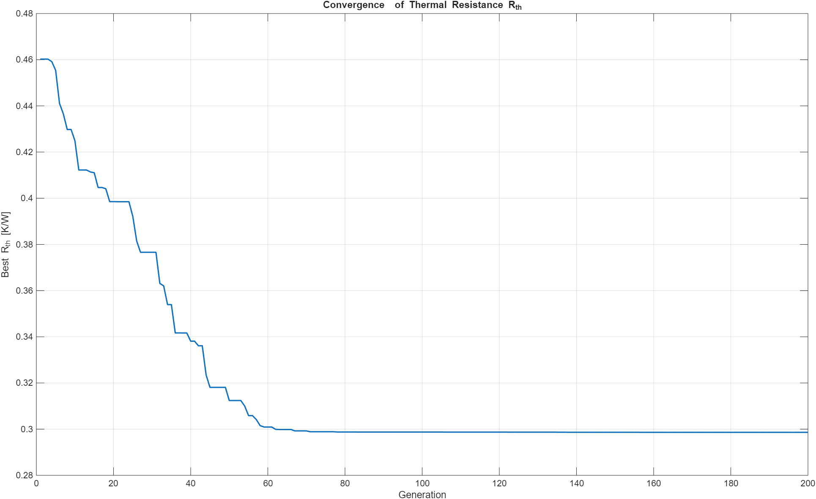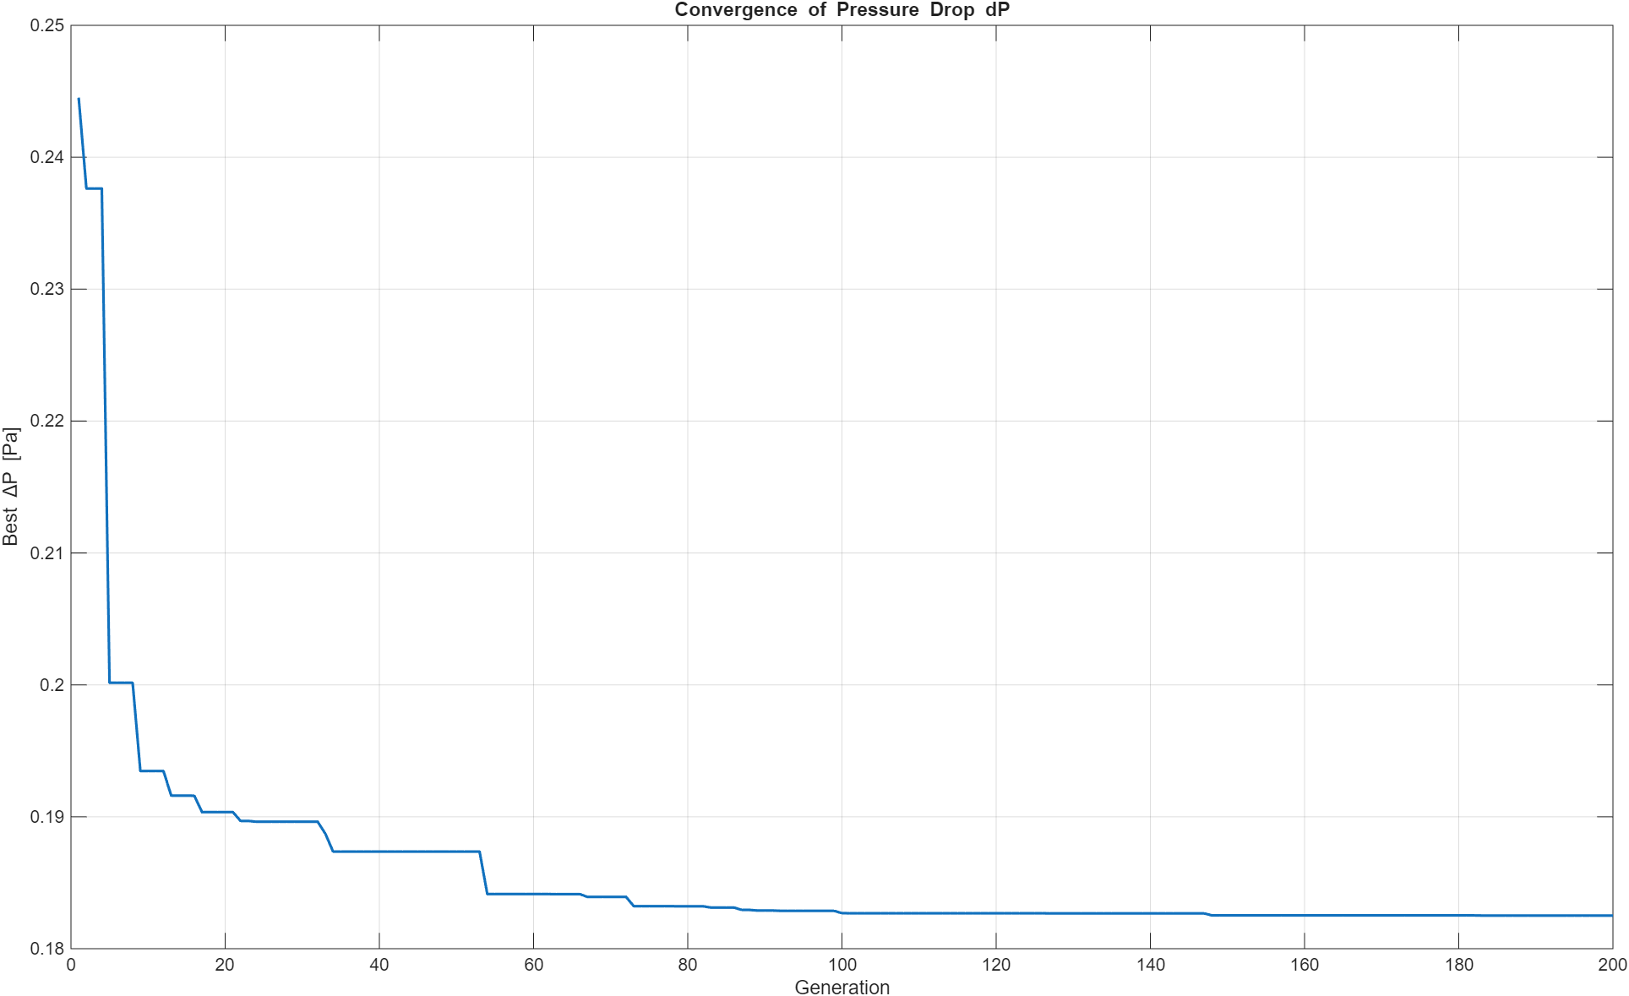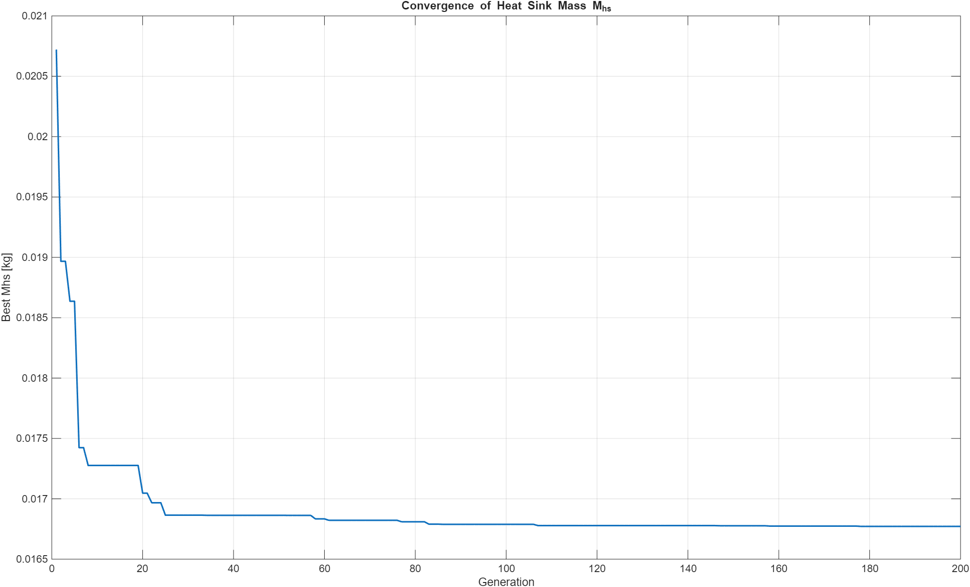
- Selection: Binary tournament based on rank + crowding distance.
- Elitism: Ensures that the best solutions from each generation are carried forward, accelerating convergence.
The algorithm is executed with a population size of 120 and 200 generations. These values were selected to ensure reliable coverage of the search space while maintaining computational efficiency. A penalty function is applied to enforce geometric feasibility and thermal limits.
The convergence profiles for all three objectives show a rapid reduction in error during the early generations, followed by gradual stabilization as the algorithm approaches the optimal trade-off region. This behavior indicates that NSGA-II efficiently explores the design space before refining solutions within a narrow performance band. The eventual plateau in each objective confirms that the population has converged to a stable Pareto set, demonstrating both algorithmic robustness and surrogate-model consistency.

5.4.4 Output: Pareto-Optimal Design Set

The final output of NSGA-II is a Pareto front representing optimal trade-offs among the three objectives. Each point corresponds to a feasible heat-sink design where, improving one performance metric inevitably worsens at least one other. Aluminum and silicon solutions appear simultaneously on the same front, allowing cross-material comparison.

The resulting Pareto front illustrates the inherent trade-offs among thermal resistance, pressure drop, and heat-sink mass. Designs with low $R_{th}$ generally require taller or denser fin structures, which increase $ΔP$ and mass, while lighter or more open geometries reduce mass and pressure drop at the cost of higher thermal resistance. The distribution of solutions across the front highlights a continuous spectrum of feasible compromises, with both aluminum and silicon configurations occupying distinct regions based on their material-dependent performance characteristics.

5.5 Multi-Criteria Decision Making (MCDM)

The Pareto front generated by NSGA-II contains a large set of non-dominated heat-sink designs, each representing a different balance among thermal resistance, pressure drop, and mass. While this front is valuable for visualizing the trade space, it does not directly identify a single “best” configuration. Multi-Criteria Decision Making (MCDM) techniques are therefore employed to rank the Pareto-optimal solutions according to their proximity to ideal performance. Three widely used MCDM methods, TOPSIS, LINMAP, and VIKOR are applied to extract representative optimal designs under different decision philosophies.
5.5.1 TOPSIS Method
The Technique for Order Preference by Similarity to Ideal Solution (TOPSIS) ranks each Pareto solution based on its distance from two reference points: the ideal solution (best values of all objectives) and the nadir solution (worst values). The normalized Euclidean distance to the ideal point $D_{i}^{+}$and to the nadir point $D_{i}^{-}$ is computed, and the relative closeness coefficient is given by:
$$C_{i}=\frac{{D_{i}}^{-}}{{D_{i}}^{+}+{D_{i}}^{-}}$$
A higher $C_{i}$ indicates a better-balanced design. TOPSIS tends to favor solutions with uniformly strong performance across all objectives.
5.5.2 LINMAP Method
The Linear Programming Technique for Multidimensional Analysis of Preference (LINMAP) identifies the solution that minimizes the weighted Euclidean distance to the ideal point. Unlike TOPSIS, which considers both ideal and nadir distances, LINMAP focuses solely on approximating the ideal vector, effectively selecting the solution that is Pareto-optimal and closest to the theoretical optimum:
$$\min_{i}{\sum_{j}{wj{\left(f_{ij}-{f_{j}}^{ideal}\right)}^{2}}}$$
LINMAP is particularly suitable when equal priority is assigned to all objectives, and the emphasis is on minimizing overall deviation from the best achievable performance.
5.5.3 VIKOR Method
The VIseKriterijumska Optimizacija I Kompromisno Resenje (VIKOR) method identifies a compromise solution that balances group utility and individual regret. For each objective, the utility measure $S_{i}$ and the regret measure $R_{i}$ are computed:
$$S_{i}=\sum_{j}{wj\frac{f_{ij}-{f_{j}}^{ideal}}{{f_{j}}^{nadir}-{f_{j}}^{ideal}}}, R_{i}=\max_{j}\left[wj\frac{f_{ij}-{f_{j}}^{ideal}}{{f_{j}}^{nadir}-{f_{j}}^{ideal}}\right]$$
A VIKOR index $Q_{i}$blends the two measures to identify a compromise solution. This method is advantageous when a balance between competing objectives is desired rather than strict minimization of a distance metric.
Fig.6. Multi-material Pareto front with MCDM-selected optimal solutions (TOPSIS, LINMAP, VIKOR) and the theoretical ideal point.
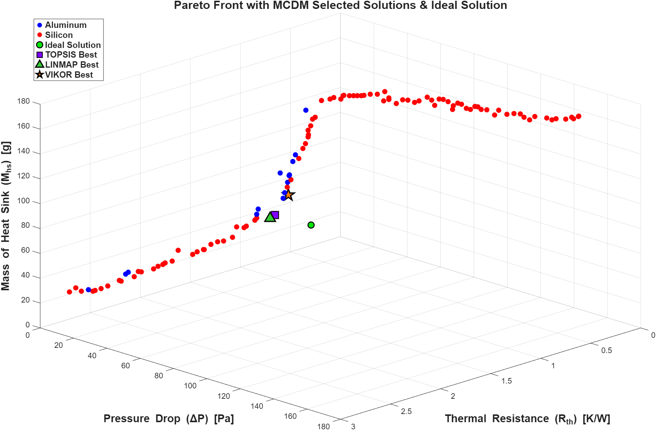
5.5.4 Application to Pareto Front
All three MCDM methods were applied independently to the final Pareto set produced by NSGA-II. The objectives were normalized, equal weighting was used for all three-performance metrics, and ranking indices were computed for each design. TOPSIS and LINMAP produced very similar solutions due to the smooth shape of the Pareto front, while VIKOR identified a compromise design slightly shifted toward lower thermal resistance.
The selected designs from the three methods provide a diverse set of representative optimal configurations. Each of these is subsequently validated through high-fidelity CFD simulation to assess the accuracy of surrogate predictions and confirm compliance with thermal performance limits.
6. Results
Table 3
Optimal Heat Sink Design Parameters selected from MCDM
Method | D (mm) | H (mm) | S (mm) | Tb (mm) | Material
TOPSIS | 2.064769 | 26.19354 | 5.313644 | 2.087853 | Silicon
LINMAP | 2.095579 | 29.40764 | 5.747766 | 2.005028 | Silicon
VIKOR | 2.567609 | 29.99934 | 5.000956 | 2.000171 | Silicon

Table 4
Decision Results of TOPIS, LINMAP and VIKOR methods
 | TOPSIS | LINMAP | VIKOR
$R_{th}$ (K/W) | 0.686411 | 0.735101 | 0.562153
$ΔP$ (Pa) | 1.824864 | 1.849347 | 2.490819
$M_{hs}$ (grams) | 34.91203 | 33.49111 | 48.31411

7. CFD Setup and Validation
High-fidelity numerical simulations were performed in ANSYS Fluent to validate the selected optimal designs obtained from the MCDM stage. The CFD analysis provides an independent evaluation of the thermal resistance, pressure drop, and heat-sink temperature field, enabling direct comparison with surrogate-based predictions and ensuring that the proposed optimal designs satisfy the thermal performance constraints under realistic operating conditions.
The CAD models were created in ANSYS Discovery based on the optimal geometric parameters. Each configuration consists of a 15 × 15 × 2 mm³ heated chip embedded beneath a 60 × 60 mm² heat-sink base of thickness $t_{b}$. Cylindrical fins of diameter $D$ and height $H$ are placed on the upper surface with uniform spacing $S$. The heat sink is enclosed within a rectangular flow domain long enough upstream and downstream to ensure fully developed inlet and outlet conditions. Chip and heat-sink volumes were split into separate bodies for assigning material properties and heat sources.
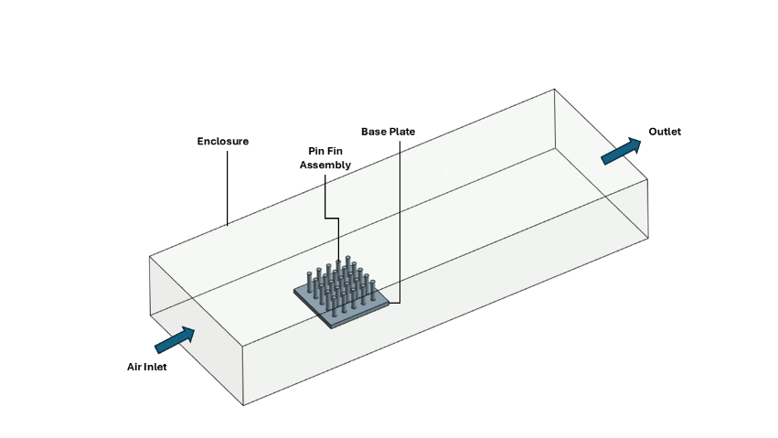
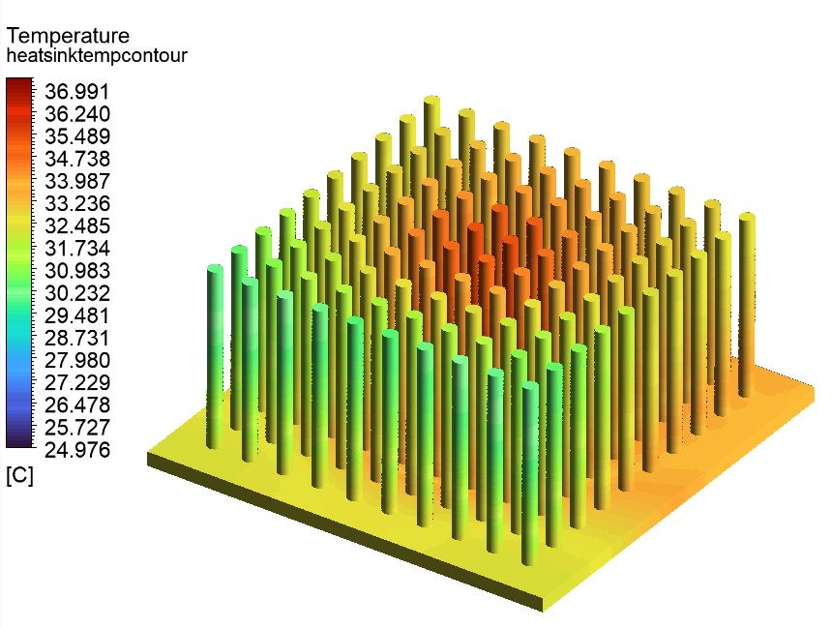
Fig.7. Schematic of the CFD simulation domain showing the enclosure, air inlet, outlet, base plate, and pin-fin heat-sink assembly.
The pressure-based, steady-state solver was employed with second-order discretization for momentum and energy equations. Coupling was achieved through the COUPLED scheme. Convergence was monitored using residual norms as well as stabilization of temperature and pressure fields. Although the solution typically converged in fewer than 300 iterations, additional iterations were permitted to ensure fully stabilized temperature fields.
The residual plot shows a steady, monotonic decrease across all governing equations, indicating stable and well-behaved numerical convergence. Momentum and energy residuals reach several orders of magnitude below the initial levels, while turbulence variables ($k$, $ω$) also exhibit smooth decay, confirming that the flow and thermal fields have stabilized. The overall convergence behavior demonstrates the reliability of the CFD solution used for validating the optimal designs.
Fig.9. CFD temperature contour visualization of the TOPSIS-selected heat-sink design showing fin-surface temperature distribution and downstream thermal plume.
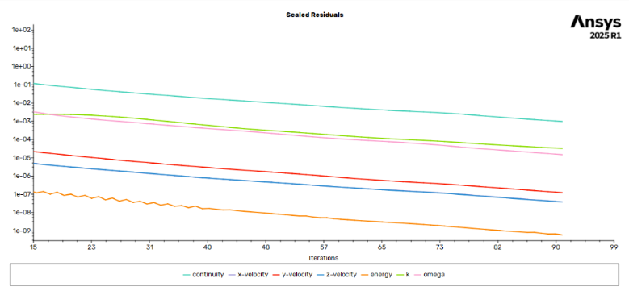
Fig.8. Convergence history of scaled residuals for the CFD simulation of the selected heat-sink design.
The CFD results for each MCDM-selected design were compared directly with surrogate predictions. Agreement between the two sets confirms the accuracy of the surrogate models and validates the NSGA-II optimization framework. Temperature contours, velocity fields, and streamline plots were additionally visualized to illustrate thermal spreading, flow development, and local hotspots within the fin array.
Table 5
Comparison of optimization-predicted and CFD-validated performance metrics for the TOPSIS, LINMAP, and VIKOR selected designs.
 | TOPSIS |  |  | LINMAP
 | $$R_{th}$$ | $$ΔP$$ | $$M_{hs}$$ | $$R_{th}$$ | $$ΔP$$ | $$M_{hs}$$
Optimization | 0.6864 | 1.8249 | 34.9120 | 0.7351 | 1.8493 | 33.4911
CFD | 0.7030 | 1.8750 | 35.600 | 0.7580 | 1.9120 | 34.300
Error % | 2.42 % | 2.75 % | 2.14 % | 3.12 % | 3.39 % | 2.41 %
 | VIKOR
 | $$R_{th}$$ | $$ΔP$$ | $$M_{hs}$$
Optimization | 0.5622 | 2.4908 | 48.3141
CFD | 0.5850 | 2.60 | 49.9
Error % | 4.05 % | 4.39 % | 3.28 %

The comparison shows strong agreement between the surrogate-based optimization predictions and the high-fidelity CFD simulations across all three selected designs. Overall, the percentage errors for all objectives stay well below 6%, demonstrating that the combined DOE–surrogate–NSGA-II framework provides reliable performance estimates.
8. Conclusion
This study presented a comprehensive multi-objective optimization framework for the thermal–hydraulic design of a pin-fin heat sink, integrating numerical modeling, surrogate approximation, evolutionary optimization, and CFD validation. Latin Hypercube Sampling enabled efficient exploration of the design space, while surrogate models, GPR for thermal resistance and mass, and ANN for pressure drop, provided accurate, low-cost predictions with errors consistently below 6%. The NSGA-II algorithm successfully produced a well-distributed Pareto front capturing the inherent trade-offs among thermal resistance, pressure drop, and heat-sink mass, with clear differentiation between aluminum and silicon configurations.
Decision-making techniques (TOPSIS, LINMAP, and VIKOR) were employed to extract representative optimal designs, all of which were subsequently validated using high-fidelity CFD simulations. The CFD results showed strong agreement with surrogate predictions and confirmed that all selected designs satisfied the thermal constraint, maintaining chip temperatures well below the maximum allowable ${60}^{∘}\text{C}$.
Overall, the proposed workflow demonstrates that combining DOE-driven surrogate modeling with NSGA-II provides an efficient and reliable methodology for optimizing complex heat-sink geometries. The validated multi-material designs provide practical configurations with balanced thermal, fluid-dynamic, and structural performance, offering a robust foundation for further refinement and prototype development.
References
[1] Parash Pai Raikar (2025). 3D optimization of heat sink fins using adjoint-based optimization with a CAD-based parameterization.
International Journal of Heat and Mass Transfer.
(https://doi.org/10.1016/j.ijheatmasstransfer.2025.127722)
[2] Miguel S. Nuñez-Aguayo (2025). Enhanced multi-objective genetic algorithm for optimized thermal management in mini heat sinks. International Journal of Heat and Mass Transfer.
(https://doi.org/10.1016/j.icheatmasstransfer.2025.109229)
[3] Hesam Moayedi (2025). Improvement of heat sink cooling performance by optimizing geometrical parameters.
International Journal of Heat and Mass Transfer.
(https://doi.org/10.1016/j.icheatmasstransfer.2025.109859)
[4] Shaswat Pathak (2025). ML-augmented CFD framework for heat sink and fan speed optimization in gaming workstations.
International Journal of Mechanical Sciences.
(https://doi.org/10.1016/j.ijmecsci.2025.110752 )
[5] Chunyan Zhao (2025). Multi-objective optimization of heat sinks with micro variable-density structures.
International Journal of Mechanical Sciences.
(https://doi.org/10.1016/j.ijheatfluidflow.2025.110079)
[6] Huizhu Yang (2025). Topological optimization design of micro pin-fin heat sinks for high heat-flux cooling applications.
International Journal of Thermal Sciences. (https://doi.org/10.1016/j.ijthermalsci.2025.110102)

